TECHNICAL PROJECT REPORT

# Title of Invention / Project:

# Controlling computer using hand gestures

# Team Members / Inventors:

|  |  |  |  |  |  |
| --- | --- | --- | --- | --- | --- |
| **S.No.** | **Name** | **Department** | **Designation** | **Mobile** | **E-Mail** |
| 1. | Ashish | ECE | Student | 9958835299 | anu21jarial@gmail.com |
| 2. | Pritika Diwan | ECE | Student | 9779799165 | [Pritika.diwan271299@gmail.com](mailto:Pritika.diwan271299@gmail.com) |
| 3. | Alekh Anand | ECE | Student | 8503063468 | anandalekh@gmail.com |
|  |
| 4. | Khushal Thakur | ECE | Mentor | 9646030764 | [khushal.thakur@cumail.in](mailto:khushal.thakur@cumail.in) |
| 5. | Anshul Sharma | ECE | Mentor | 9478697475 | [anshulsharma.ece@cumail.in](mailto:anshulsharma.ece@cumail.in) |
| 6. | Kiran Jot Singh | ECE | Mentor | 9463909689 | [kiranjotsingh.ece@cumal.in](mailto:kiranjotsingh.ece@cumal.in) |
| 7. | Divneet Singh Kapoor | ECE | Mentor | 9878422653 | [divneet.ece@cumail.in](mailto:divneet.ece@cumail.in) |

Section – 1 (IPR Related)

# Brief Abstract (500 words):

The project is solving the following problems: Reduce hardware cost by eliminating use of mouse,

convenient for users not comfortable with touchpad, the framework may be useful for controlling different types of games and other applications dependent on the controlled through user defined gestures.

To solve the above mentioned problems we are trying to make use of hand gestures. To achieve this Gesture controlling is based on specifying hand position from the ultrasonic sensor. For processing the raw data, a micro-controller is essential; for that we use Arduino UNO board. Via USB connection the micro- controller transfers the processed and calculated distance value which is provided by the sensor. The data which is send by the sensor is processed in the software in PC where all the calculations are performed and the data is matched with the predefined conditions (gesture resolution). In this model two ultrasonic sensors are used to detect hand position and are connected to the Arduino board .As we know ultrasonic sensor continuously emits sound and it gets reflected back from user’s hand. The distance between the sounds is send and detection of reflect back sound wave is calculated by the micro-controller.

# Existing state-of-the-art and Drawbacks in existing state-of-the-art

|  |  |  |
| --- | --- | --- |
| **S. No.** | **Existing state of art** | **Drawbacks in existing state of art** |
| 1. | US7665041B2 | Manipulating on – screen objects through hand gestures and verbal commands. |

# Novel/Additional modifications that you can propose to improve upon drawbacks

Since the use of verbal commands may sometimes not detect the voice of the user so this project is not implementing the use of verbal commands.

# Advantages

* The main advantage of using hand gestures is to interact with computer as a non – contact human computer input modality.
* This technique may be very useful for those who does not know functionally of computer. This technique decreases the learning time required.
* A number of functions of computer can be operated by using ultrasonic sensor.
* For this system there is no need of sound to be created so no interruption of background noise By using this system we can control our laptop from a small distance and it can help to control laptop in conference room presentation.
* Using this technique it is easy to interact with the computer and there is no language barrier.

# Block Diagram

**Hand Detected**

Hand Detected

Section – 2 (Real Project)

# Materials

|  |  |  |
| --- | --- | --- |
| S.No. | Hardware Components | Software Components |
| 1. | 1 Arduino UNO | Arduino IDE |
| 2. | 2 Ultrasonic Sensors | Python IDLE, Pyautogui Library |
| 3. | 1 Set of Jumper wires | PySerial Library |

# Circuit Diagram

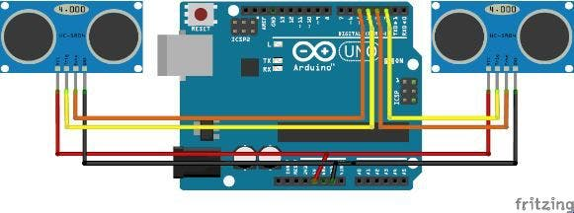

# Steps of Circuit Completion

Step 1:

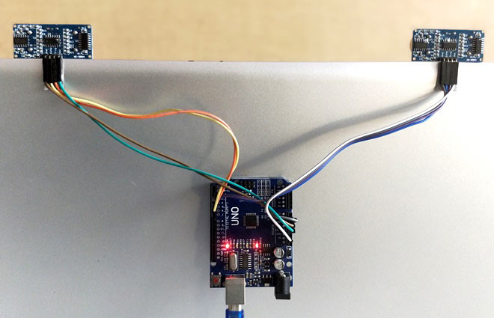

Step 2: 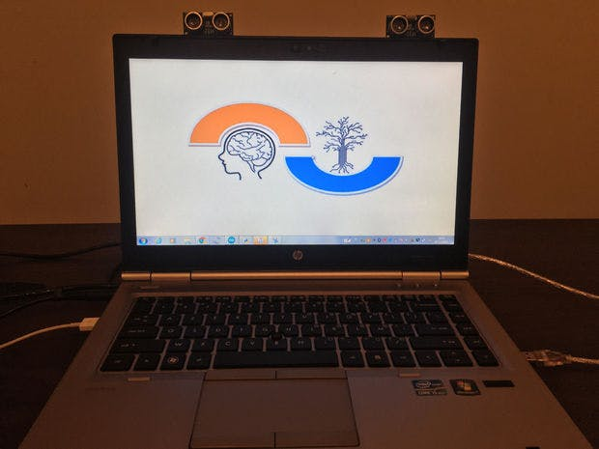

# Program Code